**Recommendations for Big Mountain Resort**

This project is to explore the opportunities for Big Mountain Resort to increase the revenue by at least 1.54 million this season by cutting costs or lifting the ticket price.

**Findings from EDA and modeling**

The EDA and modeling figure out 8 important features related to the ticket price.

* vertical_drop
* Snow Making_ac
* total_chairs
* fastQuads
* Runs
* LongestRun_mi
* trams
* SkiableTerrain_ac

By comparing with other resorts in the nation, Big Mountain is high up the league table of these key facilities. Regarding ticket price, there are a good number of resorts in the nation that have a higher ticket price as shown in the figure below.

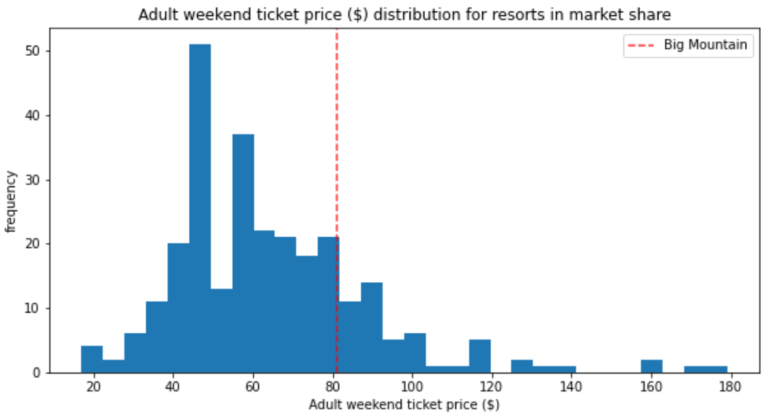

The current ticket price of the Big Mountain Resort is $81.00. The model suggests a much higher price of $95.87by considering the facilities of resorts in the marketplace. In other words, the model suggests there is room for an increase in the ticket price. Considering the aforementioned key facilities, four scenarios are tested for ticket price change.

**Four scenarios for the ticket price increase**

We considered four options below in the developed model to predict the ticket price increases.

* Scenario #1: Permanently closing down up to 10 of the least used runs. This doesn't impact any other resort statistics.
* Scenario #2: Increase the vertical drop by adding a run to a point 150 feet lower down but requiring the installation of an additional chair lift to bring skiers back up, without additional snow-making coverage
* Scenario #3: Same as number 2, but adding 2 acres of snow-making cover
* Scenario #4: Increase the longest run by 0.2 miles to boast 3.5 miles in length, requiring additional snowmaking coverage of 4 acres

The predictions on the ticket price increase and revenue increase over the season derived from the model have been summarized in the table below. Note that the revenue is calculated with the assumption that the expected number of visitors over the season is 350,000 and, on average, visitors ski for five days.

|  |  |  |  |  |
| --- | --- | --- | --- | --- |
| Scenario | #1 | #2 | #3 | #4 |
| Ticket price increase, $ | [-1.81,0] | 1.99 | 1.99 | 0 |
| Revenue increase over the season, $ | [-3170289.85, 0] | 3,474,638 | 3,474,638 | 0 |

In scenario #1, The ticket price increase is negative. It means closing used runs yields a decrease in the ticket price. The figure below shows dynamic ticket price and revenue changes as closing 1-10 used runs. It illustrates that closing down one run makes no difference. Closing 2 and 3 successively reduces support for ticket price and so revenue. If Big Mountain closes down 3 runs, it seems they may as well close down 4 or 5 as there's no further loss in the ticket price. Increasing the closures down to 6 or more leads to a large drop. It is worthwhile noting that closing down runs will cut the operational cost accordingly. Therefore, if the operational cost of runs is provided, we may find a balanced number of closed runs so that the revenue change is not negative.

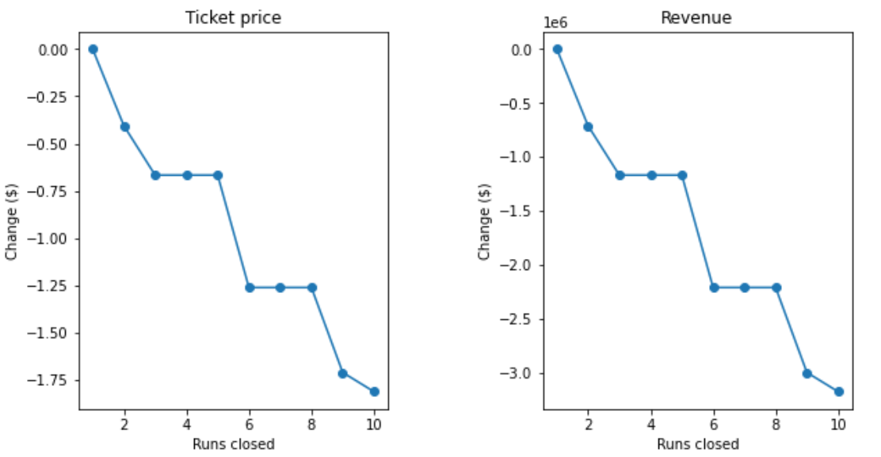

Scenario #2 increases support for ticket price by $1.99. Over the season, this could be expected to amount to $3,474,638. Scenario #3 makes no difference than scenario #2, even though it slightly increases the snow-making area by 2 acres. Scenario #4 has no effect on the ticket price and the revenue, implying that increasing the longest run by 0.2 miles doesn’t support the ticket price and the revenue.

In summary, scenario #2 yields the best results. It is recommended to increase the vertical drop by adding a run to a point 150 feet lower down and install an additional chair lift to bring skiers back up. It increases the revenue by 3.47 million, which can cover the additional operational cost of 3.08 (1.54×2) million for two new chair lifts. If the operational cost of runs are given, we may further optimize the number of runs.